
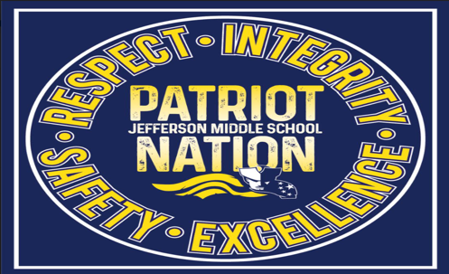
R

RESPECT
Cafeteria
EXPECTATIONS

Transit
B

- Be understanding and flexible
- Be friendly and include others
E
EXCELLENCE
- Enter cafeteria calmly
- Wait in line patiently
- Keep the noise level down
S
SAFETY
- Place litter in trash cans
- Remain seated while eating
- Use good manners
I
INTEGRITY
- Use appropriate language
- Be polite and use “please” and “thank you”

